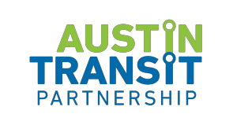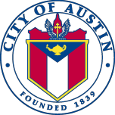

PROJECT CONNECT COMMUNITY ADVISORY COMMITTEE
Special Called Meeting

August 26, 2021
4:45 pm to 7 pm

- Call to Order
- Public Comment
- Land Acknowledgement
- Executive Session
- Adjourn

